To: The Record

From: Don Bellenger

Subject: Set up new site in Github, Donport, and Hostek

Date: 08/16/2018

To set up a new repository

<https://github.com/>, and select “New Repository”

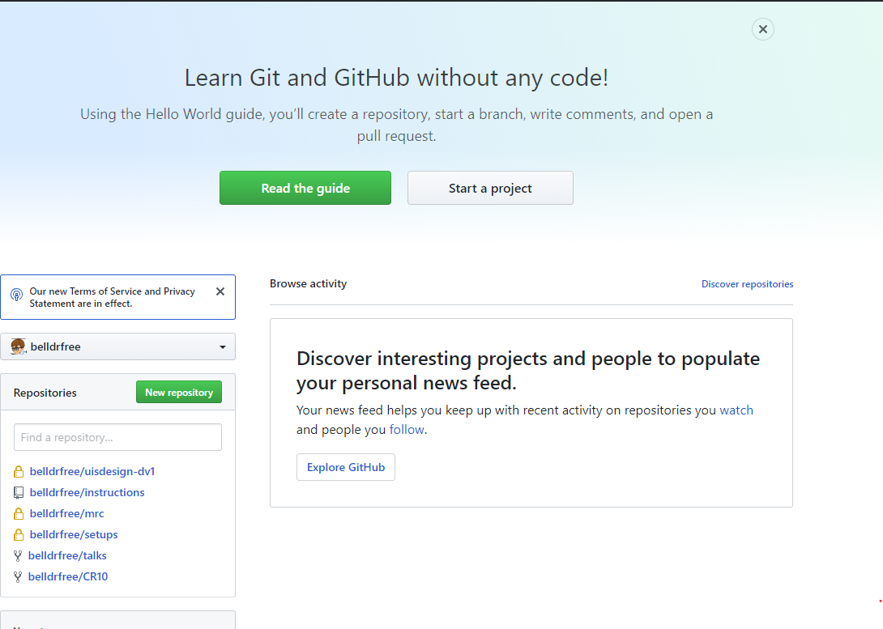

Private, with a README

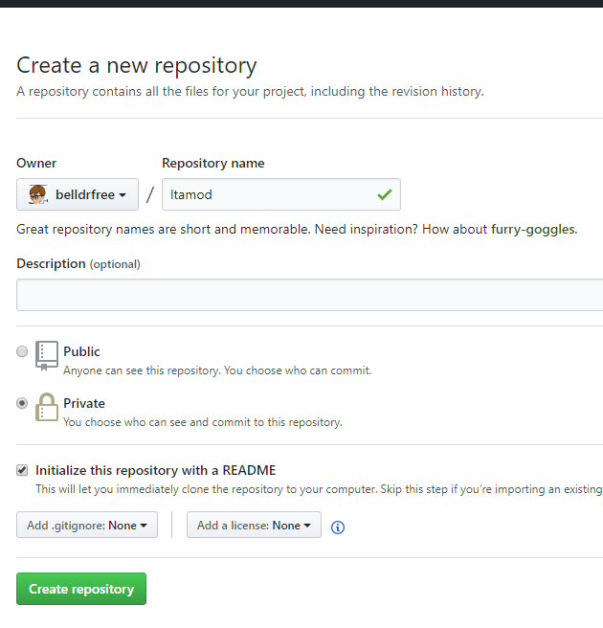

Update the readme, and commit to Master

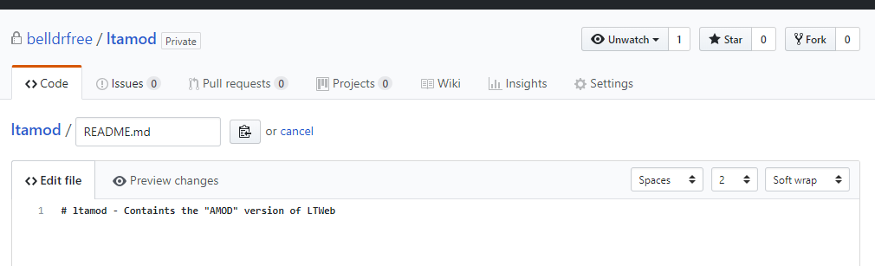

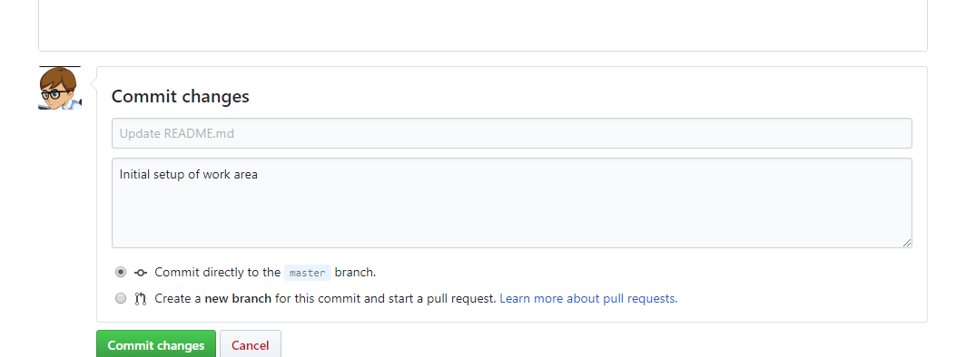

On DONPORT4, create the corresponding work area. In this case, we want a NEW folder under cbsites, connecting to the repository just created, and using a putty key for ease of logging in.

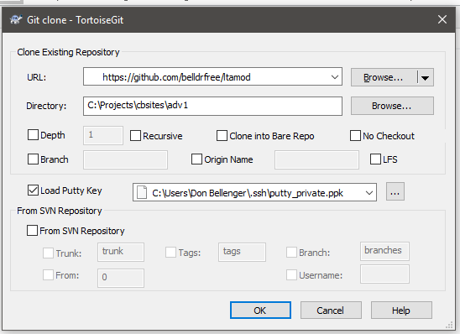

Create ADEV, ATEST, and APROD branches.

git bash here

git checkout -b ADEV

git push origin ADEV

git checkout master

(repeat for ATEST and APROD)

Finally, git checkout ADEV

Copy in or create the code you want to check in (on the ADEV branch)

Push to github

Use remote desktop to log into Hostek, browse to home. Right click on uisdesign, and git clone. Enter

Repository created above, clone into C:\home\uisdesign.com\adev, and use putty key.

Cd to uisdesign/adev, right click, checkout branch remotes/origin/ADEV, pull. On the pull, let it create the tracking branch. This is equivalent to git checkout -t ADEV.

This gets the code.

Use Hostek Mocha Control Panel: <https://wcp.hostek.com/login.aspx>, and Add Sub Domain

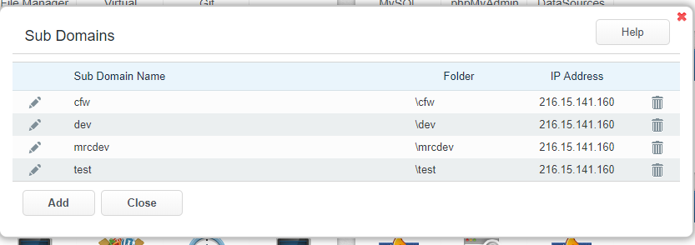

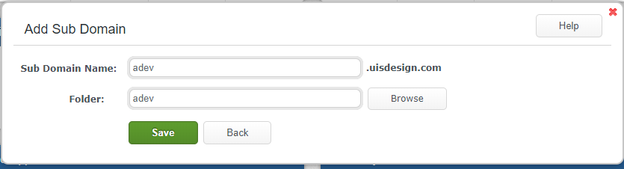

In chrome, make a bookmark for <http://adev.uisdesign.com/>. That’s it!